SPM TOOLBOX
Objective
This project aims to create a Flutter-based mobile app to support students and professionals in mastering Software Project Management (SPM) concepts through practical tools :
- Cost Benefit Analysis
- Process Model Selection
- PERT Estimation
- Critical Path Calculation
The app bridges theoretical SPM knowledge with hands-on application.
Code Snippets for Key Functions
- Cost Benefit Analysis
CostBenefitResult calculateCBA(double initial, List<double> flows, double rate, int lifespan) {
double npv = -initial + flows.asMap().entries.map((e) => e.value / pow(1 + rate, e.key + 1)).reduce((a, b) => a + b);
double netProfit = flows.reduce((a, b) => a + b) - initial;
double roi = netProfit / initial * 100;
return CostBenefitResult(
initialInvestment: initial,
cashFlows: flows,
discountRate: rate,
projectLifespan: lifespan,
netProfit: netProfit,
averageAnnualProfit: netProfit / lifespan,
roi: roi,
npv: npv,
irr: 0.0, // Simplified; actual IRR requires iterative calculation
npvCalculationTable: [],
irrComparisonTable: [],
);
}

- Process Model Selection
ProcessModelResult selectProcessModel(String projectType) {
if (projectType == "small") {
return ProcessModelResult(
modelName: "Waterfall",
justification: "Simple, predictable projects",
characteristics: ["Linear", "Defined stages"],
);
} else {
return ProcessModelResult(
modelName: "Agile",
justification: "Flexible, iterative projects",
characteristics: ["Iterative", "Adaptive"],
);
}
}

- PERT Estimation
PertEstimationResult calculatePERT(List<PertActivity> activities) {
for (var act in activities) {
act.expectedTime = (act.optimisticTime + 4 * act.mostLikelyTime + act.pessimisticTime) / 6;
act.variance = pow((act.pessimisticTime - act.optimisticTime) / 6, 2);
}
var criticalPath = []; // Logic to determine critical path (simplified here)
double totalDuration = activities.map((a) => a.expectedTime!).reduce(max);
double totalVariance = activities.map((a) => a.variance!).reduce((a, b) => a + b);
return PertEstimationResult(
activities: activities,
criticalPath: criticalPath,
totalProjectDuration: totalDuration,
totalVariance: totalVariance,
standardDeviation: sqrt(totalVariance),
zScore: 0.0, // Requires target time input
completionProbability: 0.0, // Simplified
);
}

- Critical Path Calculation
void calculateCriticalPath(List<Activity> activities) {
// Forward Pass
for (var activity in activities) {
activity.earlyStart = activity.predecessors.isEmpty
? 0
: activities.where((a) => activity.predecessors.contains(a.id)).map((a) => a.earlyFinish).reduce(max);
activity.earlyFinish = activity.earlyStart + activity.duration;
}
// Backward Pass
var maxFinish = activities.map((a) => a.earlyFinish).reduce(max);
for (var activity in activities.reversed) {
activity.lateFinish = activity == activities.last ? maxFinish : activities.where((a) => a.predecessors.contains(activity.id)).map((a) => a.lateStart).reduce(min);
activity.lateStart = activity.lateFinish - activity.duration;
activity.totalFloat = activity.lateStart - activity.earlyStart;
activity.isCritical = activity.totalFloat == 0;
}
}

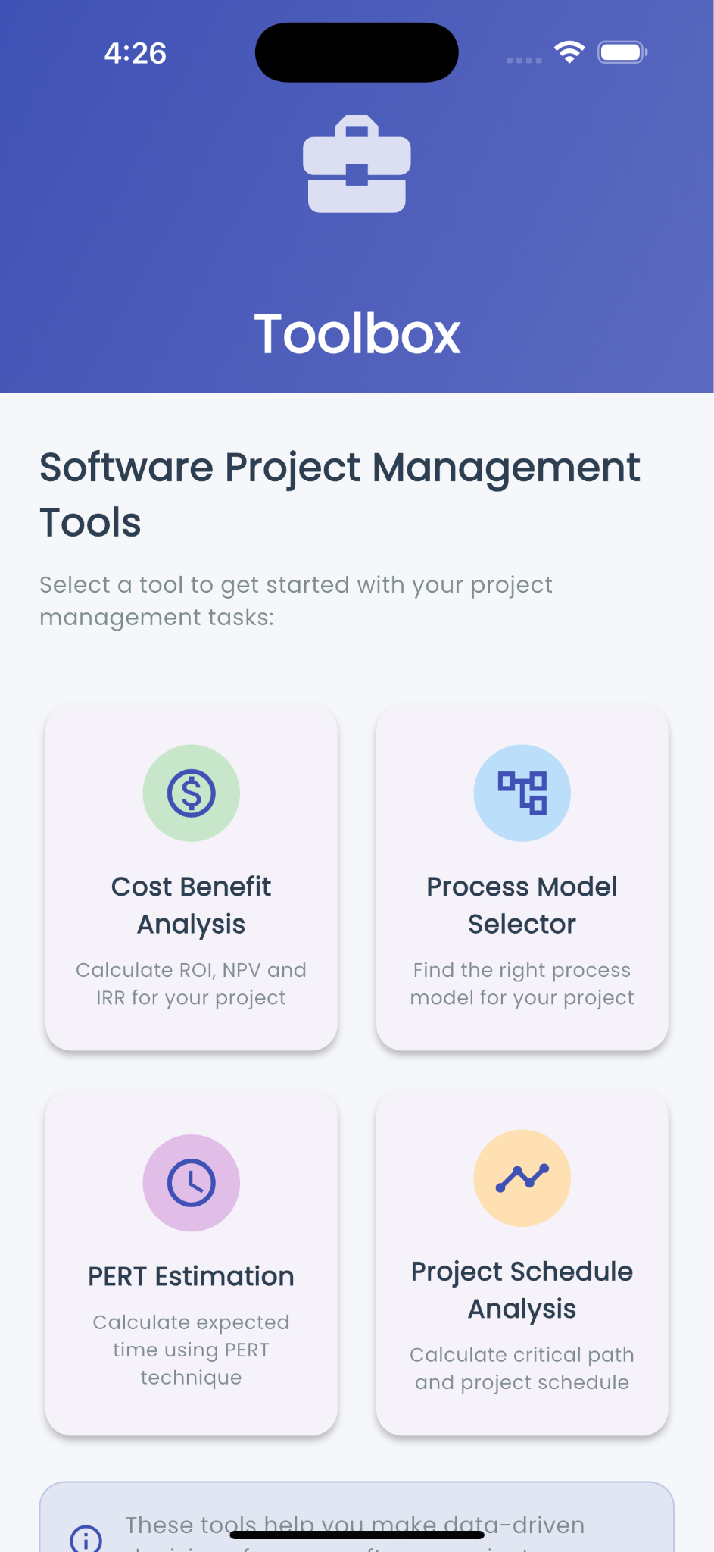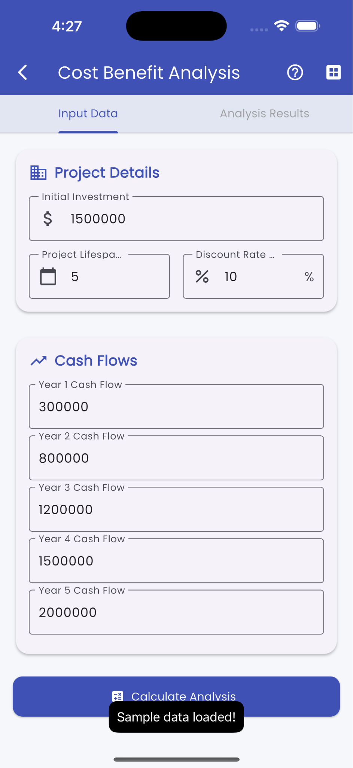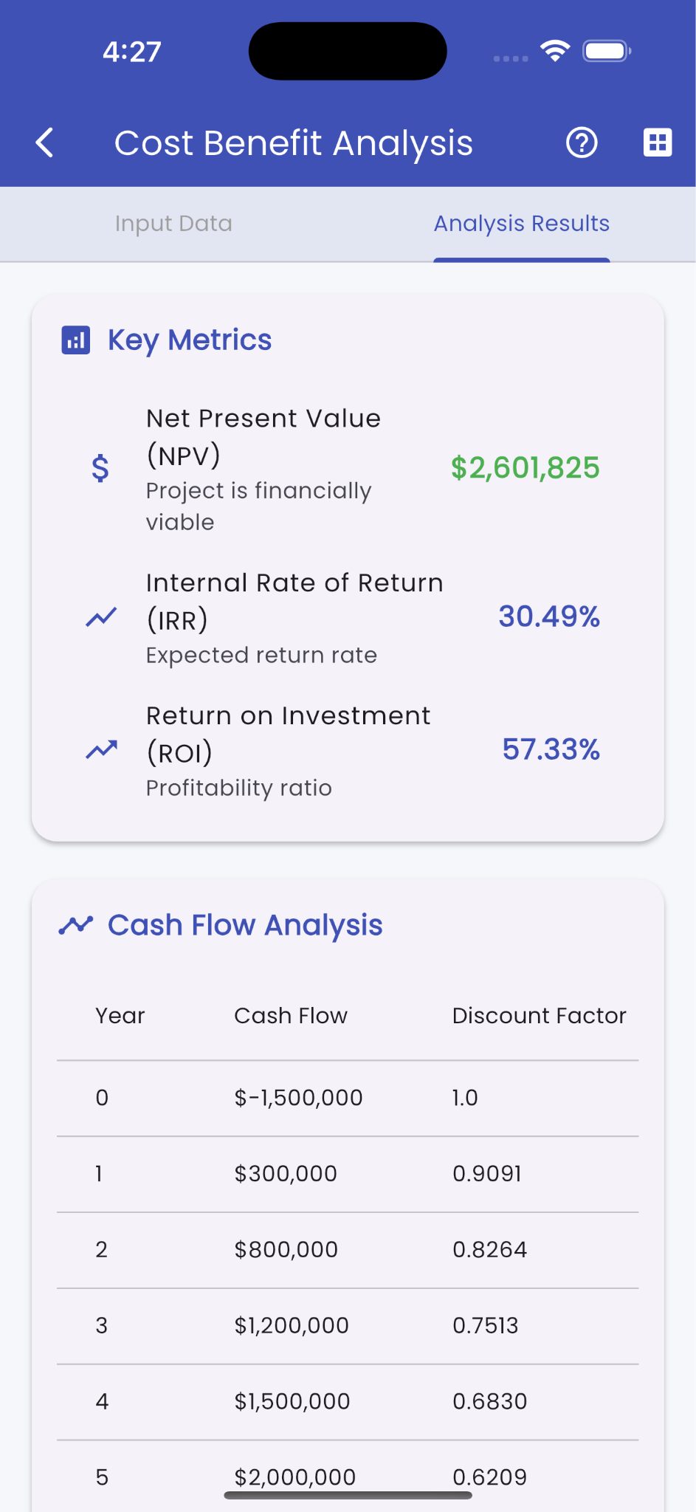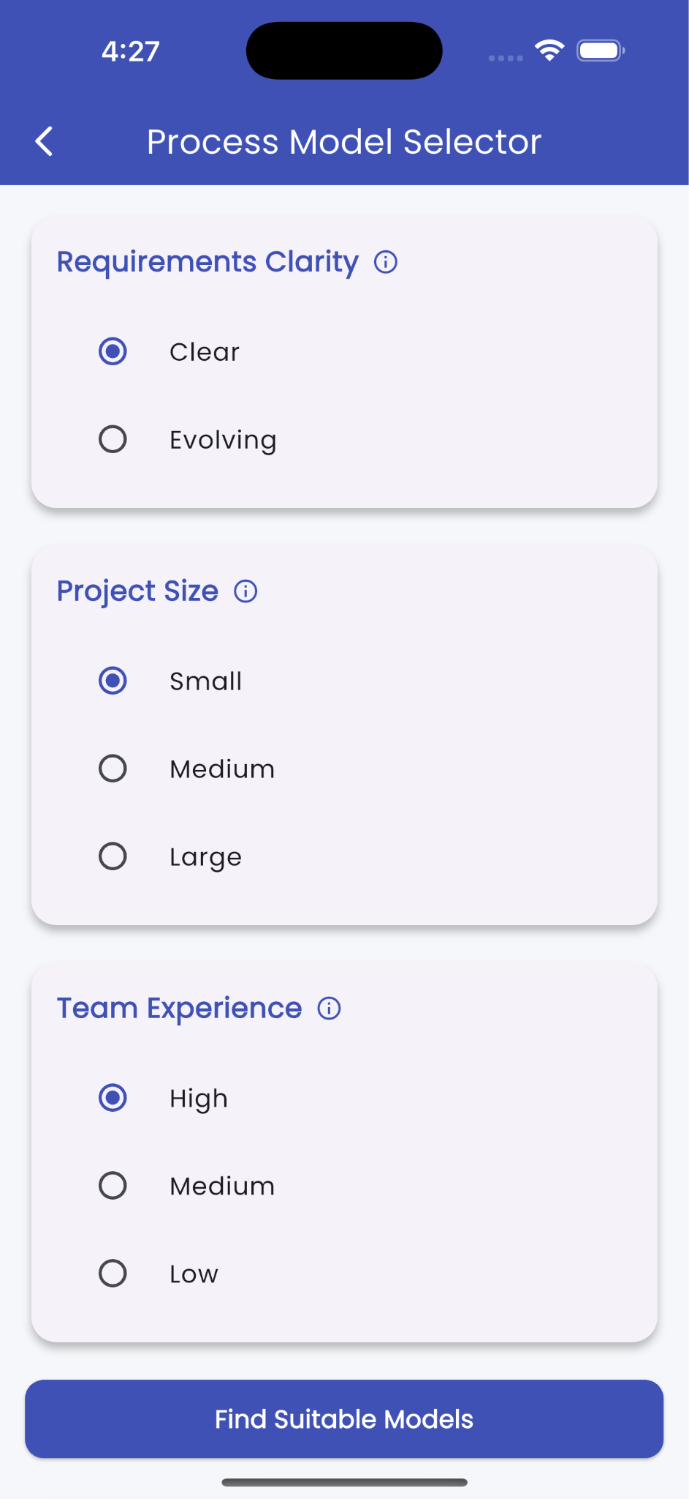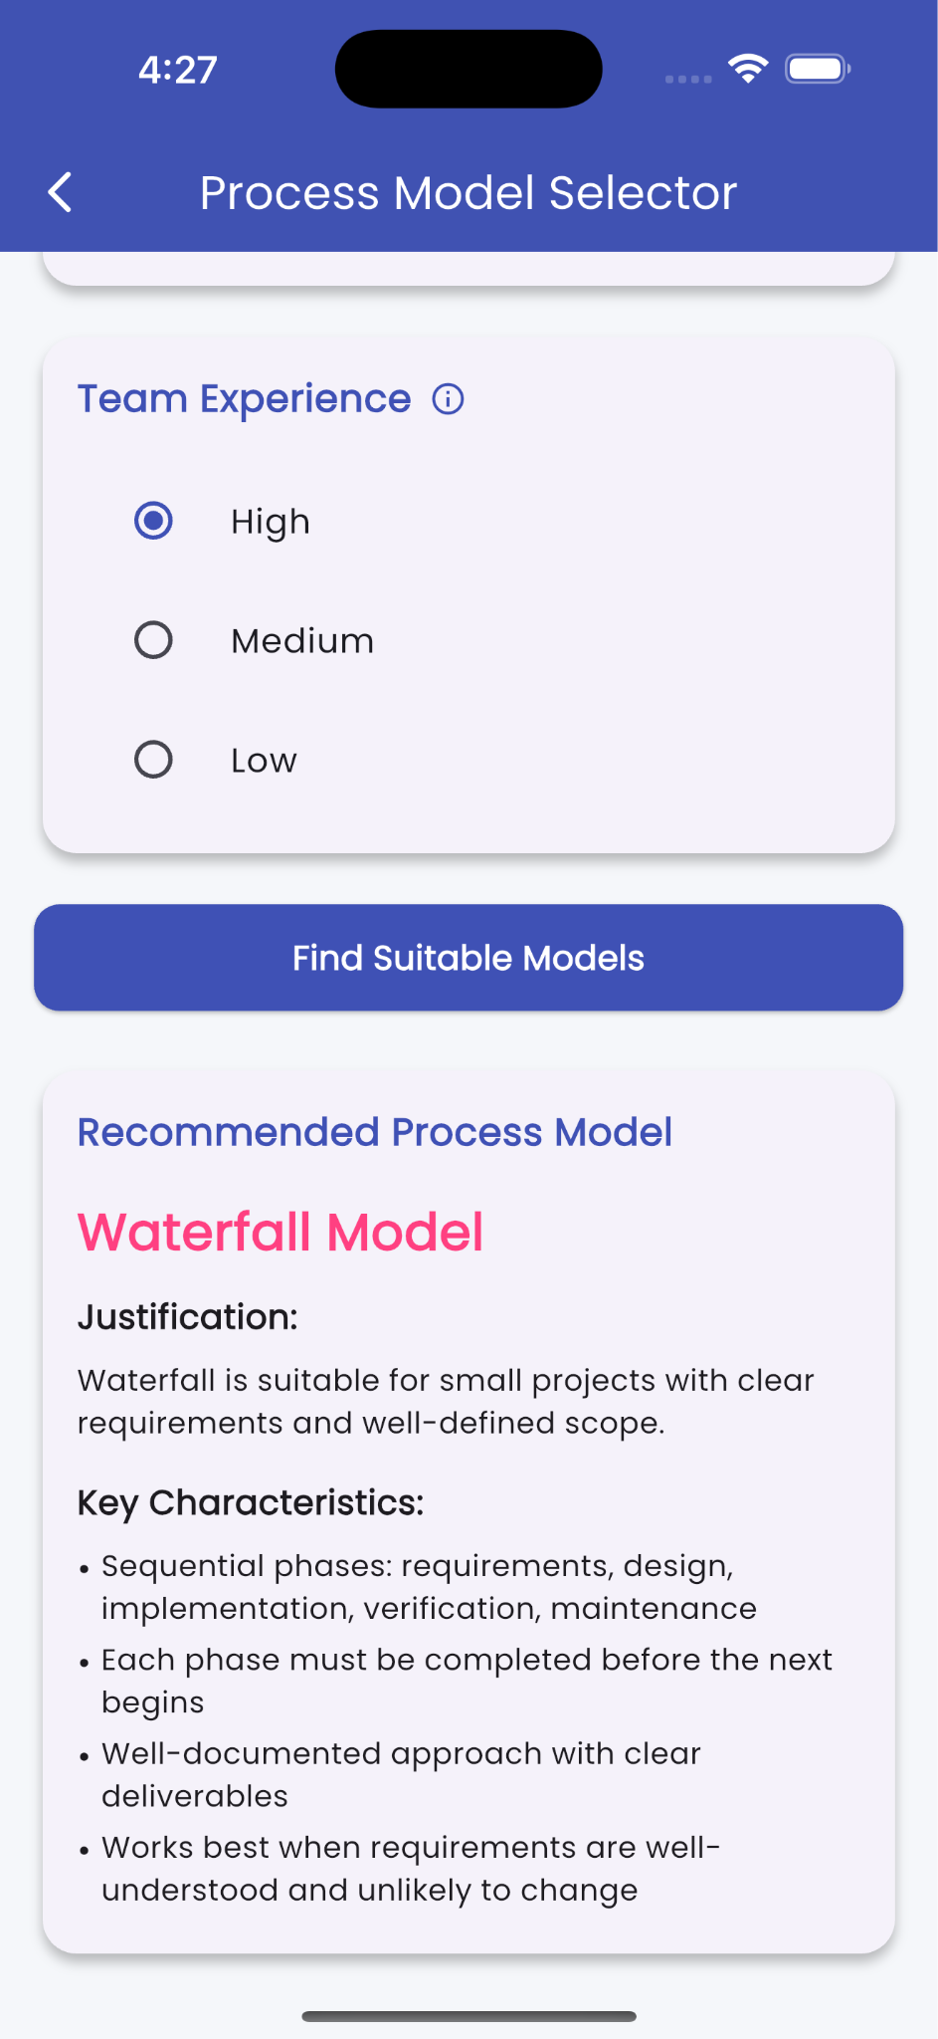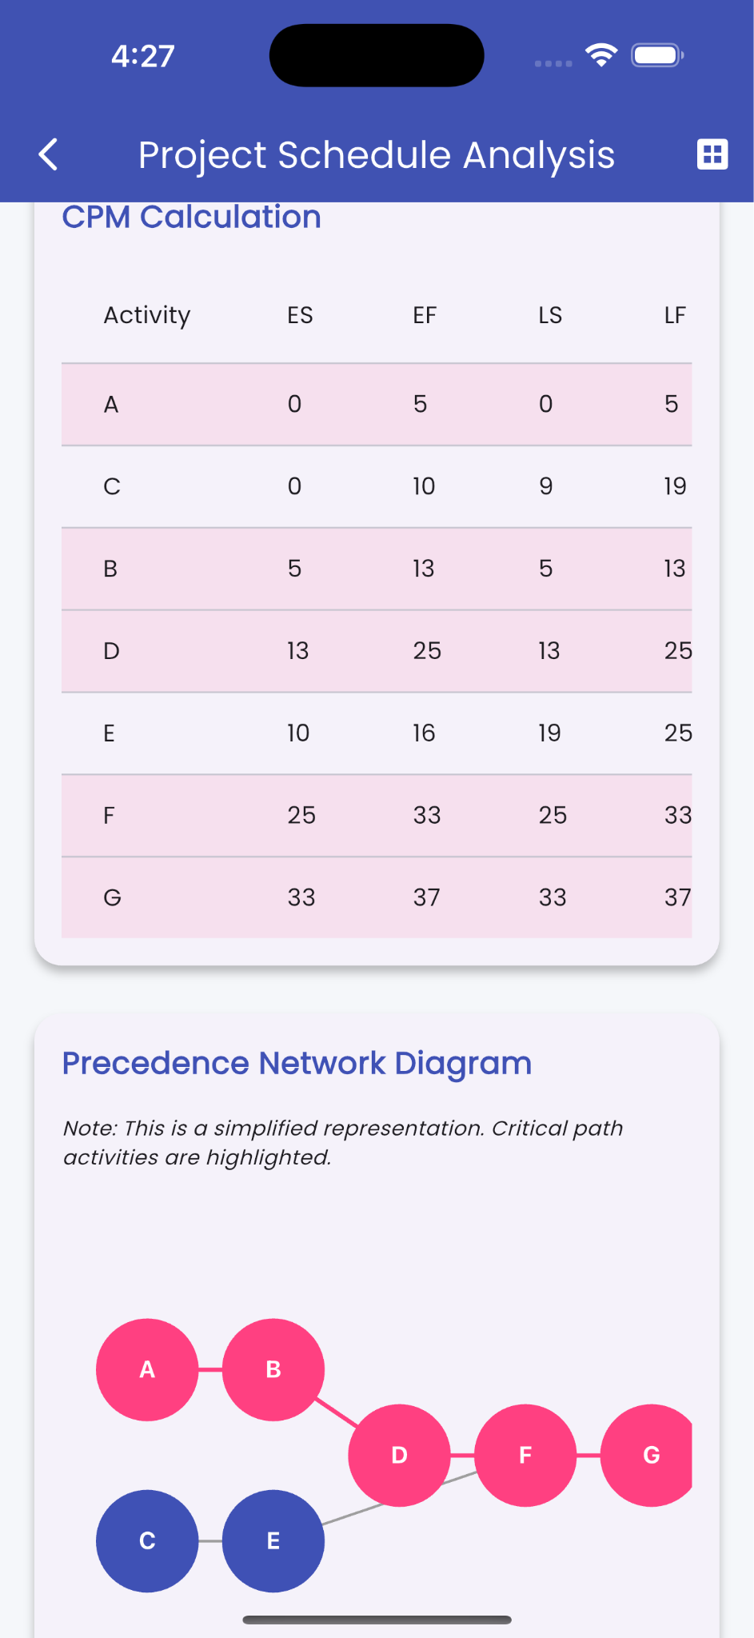

Tools / Technologies
- Flutter (UI toolkit for natively compiled mobile applications)
- Dart (Programming language for Flutter)
- VS code (Development environment)
- Firebase (optional – if used for data storage or analytics)
- Git & GitHub (for version control)

Future Scope

Include Risk Analysis and Resource Planning tools
- Export results to PDF or Excel.
- Add user accounts for saving project data.
- Integrate cloud database to store and retrieve project history.
- Add AI-based suggestions for model selection or cost estimation.

